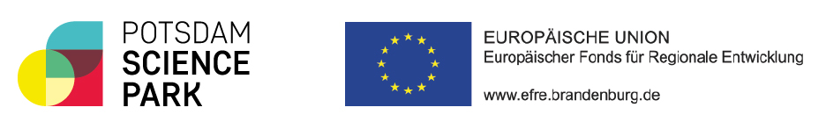
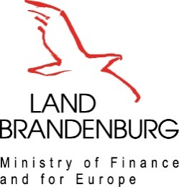

Invitation
International Forum - Innovation hubs for regional development
Experiences, challenges, solutions

The Ministry of Finance and European Affairs of the State of Brandenburg and the Potsdam Science Park are pleased to invite you to the International Forum “Innovation hubs for regional development: Experiences, challenges, solutions” taking place on September 6th–7th 2022 in Potsdam, Germany.

Innovation hubs play a key role in the development of regions by bringing together science and business, often providing the environment for the creation of new innovative companies.
Five years into the development of Potsdam Science Park into an innovation hub with many stakeholders, this Forum aims at engaging with international partners. The Forum will focus on very practical discussions, on strategies and challenges when developing and managing innovation hubs. Based on shared experiences, participants will identify common challenges, develop solutions and – where useful – prototype joint projects to address challenges together.
The Forum brings together decision makers and experts developing and managing innovation hubs, in particular managements of innovations hubs as well as partners from the public sector (in particular regional and local administration), the private sector and non-profit organisations.

On day 1 we will give you the opportunity to introduce your organisation to your peers, before our key note speaker will give you important insights into the Strategic Development of Science Parks. You will have plenty of time to ask questions and discuss your opinions with our expert and all the other participants.

During the next session, you will work together with your peers in one of the three workgroups, all of which are led by experienced professionals. You will select the challenge you wish to work on in advance during registration.

On day 2 each workgroup will present their challenge and solution ideas in order to exchange all the individual experiences from the other working groups. By the end of the Forum you will leave rich of new ideas and solutions for your organisation.

Learn more about facilitating innovation, get to know your peers and give your organisation the opportunity to become more visible seen in an international environment.

Programme and registration for this event:
https://events.potsdam-sciencepark.de/e/REGISTRATION-INTERNATIONAL-FORUM-POTSDAM

You will receive detailed information on hotel rates and travel after registration.

We are looking forward to welcoming you in Potsdam!

With kind regards

Reiner Kneifel-Haverkamp
Director General for European and International Affairs
Ministry of Finance and European Affairs of the State of Brandenburg

Agnes von Matuschka
Managing Director, Potsdam Science Park, Standortmanagement Golm GmbH

